
ATAR Biology

Unit 1: Topic 4
Human Activities

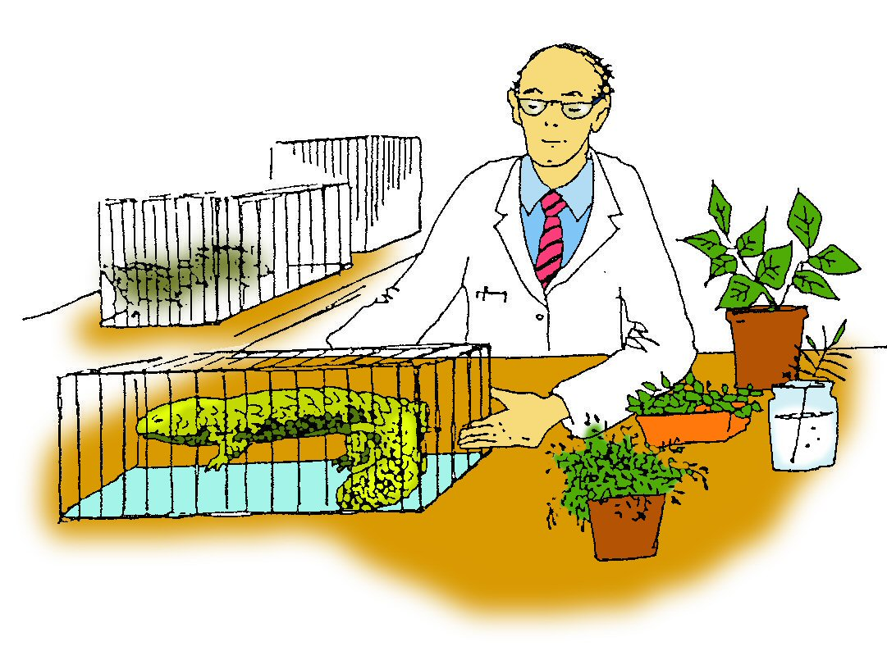

Student Study Notes

Unit Content
- Human activities that can affect biodiversity and can impact on the magnitude, duration and speed of ecosystem change include examples of:
  - habitat destruction, fragmentation or degradation
  - the introduction of invasive species
  - unsustainable use of natural resources
  - the impact of pollutants, including biomagnification
  - climate change.
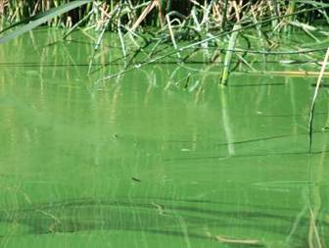

Eutrophication
Eutrophication is the enrichment of waterways with nutrients, resulting in excessive algal growth or algal bloom.

Causes
Australian soils are traditionally low in nutrients such as nitrogen and phosphorus. To make these soils suitable for crops, fertilisers are added. The nutrients which find their way into waterways through run-off cause algal bloom.
Algal bloom at Herdsman Lake, Perth W.A. (April 2009). Reproduced with permission from Noelene Harris.

Consequences
The algal bloom depletes oxygen supplies which it needs for cellular respiration, eventually causing the bloom to collapse or die and become detritus. Bacteria then decompose the detritus, further depleting the oxygen supply in the water, which results in the death of many invertebrates and fish. Algal bloom also prevents light, needed for photosynthesis, from reaching plants such as seagrass.

Example: Peel-Harvey Estuary
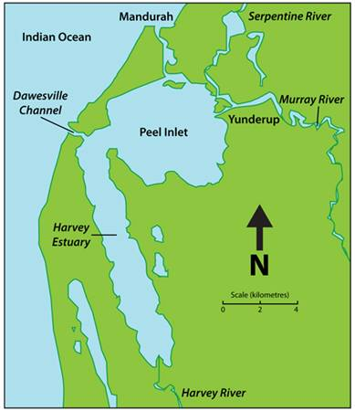
An example of where eutrophication has occurred is the Peel-Harvey Estuary 70 km south of Perth, Western Australia. The land surrounding the Peel-Harvey Estuary was cleared for farming and urban development. Fertilisers containing nitrogen and phosphorus were added to the nutrient deficient soils. These washed into the Estuary during heavy rains and led to the gradual eutrophication of the Estuary over a number of decades.
There was the periodic blooming of algae followed by a depletion of oxygen in the surrounding water. The whole system would then collapse and become detritus. Decomposition of the detritus by bacteria would then produce stinking, black ooze. This is an example of eutrophication.
Recent government water quality improvement plans aim to reduce phosphorus discharges into the Estuary through changes in agricultural and urban practices over the next few years.
The algae causing most concern were Nodularia. These single-strand filamentous algae have the added side effect of releasing a toxin.
An ecological study of the area was undertaken. Feeding relationships within the Estuary were recorded so that the position of Nodularia within the community could be established.

This can be seen in the food web shown below.

Reproduced with the permission of the Department of Education and Training

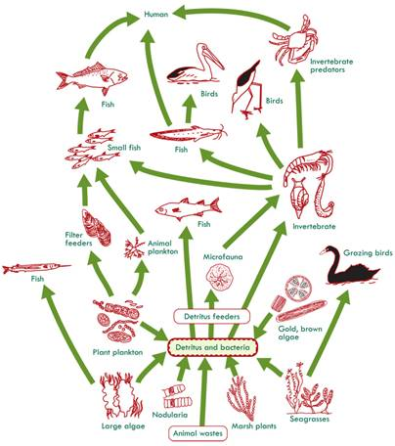

There is a link between phosphorus runoff into the Peel-Harvey estuary and the incidence of Nodularia blooms.

See if you can work out what relationship exists between river flow, phosphorous load and Nodularia bloom.

Studies have shown that Nodularia blooms occur most readily when river flow is high delivering large amounts of phosphorous to the estuary. For example, in 1981 over 300 billion litres of water brought 130 tonnes of phosphorous to the estuary causing a record Nodularia bloom.

To address the problem of phosphorus load, the Peel Inlet Management Authority has developed a three-part strategy:
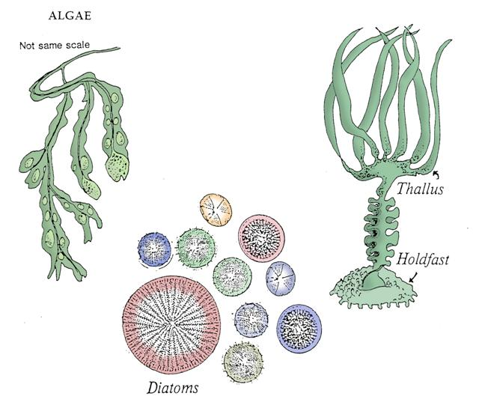
- reduce the flow of phosphorus from all significant sources in the catchments
- continue harvesting macroalgae when necessary
- increase flushing to the ocean.

The increase in flushing was achieved with the construction of the Dawesville Channel which was completed in 1994. Use the diagram of the Peel-Harvey estuary to locate the channel. Since the opening of the channel there have been dramatic reductions in the concentrations of algae and no recorded blooms of Nodularia. The salinity levels and the concentrations of dissolved oxygen have increased. This has resulted in a reduction of stratification and a decrease in release of inorganic nutrients from sediments.

The enhanced greenhouse effect

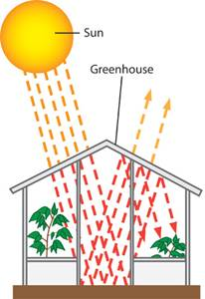
The sun's warmth passes through the glass of a greenhouse. The glass then holds much of the warmth inside. The greenhouse effect is used to model global warming and show how greenhouse gases, such as carbon dioxide, in the atmosphere trap heat from the sun.
The enhanced greenhouse effect refers to the trapping of additional heat from the sun due to an increase in greenhouse gases, which causes accelerated global warming.

Global warming
Have you ever wondered why the earth has an average surface temp of 15 °C, yet the moon, which is approximately the same distance from the sun, is much colder with an average surface temp of -18 °C?
The main reason is atmosphere. The earth has an atmosphere and the moon does not. The earth's atmosphere acts like a blanket around the earth, trapping heat and keeping it warm.

The earth's atmosphere contains greenhouse gases which allow radiant energy from the sun to enter the atmosphere and reach the earth's surface but prevents long wave, infra-red radiation from escaping. Radiation from the sun includes UV radiation which causes skin cancer and sunburn; visible radiation which allows us to see and infra-red radiation which results in heat.
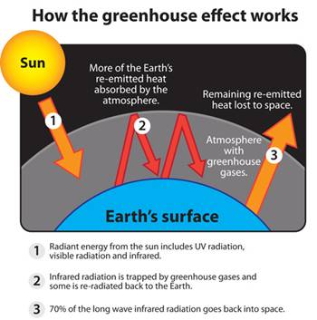
Much of the sun's radiant energy that reaches the earth's surface is absorbed by the earth and radiated back into the atmosphere as longer wavelength infra-red radiation.
Approximately 70 per cent of the radiation from the earth's surface escapes into space, but some is absorbed by the greenhouse gases in the atmosphere and re-radiated back towards the earth.

Since infra-red radiation causes heating, the atmosphere becomes hotter. This trapping of heat in the atmosphere is known as the 'greenhouse effect' and results in global warming. Global warming is caused by a build-up of greenhouse gases in the earth's atmosphere.

Natural greenhouse gases include:
- Carbon dioxide (CO2)
- Water vapour (H2O)
- Methane (CH4)

All of the natural greenhouse gases have increased over the last 200 years due to human activity.
Additional greenhouse gases or pollutants include:
- Nitrous oxide (N₂O)
- Chloroﬂuorocarbons (CFCs)
- Ozone (O₃) at ground level.

Carbon dioxide (CO₂) is the most abundant of the greenhouse gases and is responsible for 55% of global warming. Carbon dioxide levels in the atmosphere have increased due to changes in the carbon cycle - more fossil fuels are burnt and photosynthesis is reduced during large scale deforestation and land clearing.

Consequences
Carbon dioxide and other greenhouse gases in the atmosphere trap solar heat reflected from the earth's surface. Increased levels of carbon dioxide result in an 'enhanced greenhouse effect' or accelerated global warming.

Biomagnification

Biomagniﬁcation is the accumulation of non-biodegradable pollutants such as pesticides, heavy metals and radioactive material in a food chain. These pollutants tend to enter a food chain at the producer or lower levels and accumulate at the consumer or higher levels along the food chain.

Causes
The use of non-biodegradable pesticides, heavy metals and radioactive material.
Examples:
- pesticides that accumulate: DDT and dieldrin.
- heavy metals that accumulate: mercury, lead and cadmium.
- radioactive materials that accumulate: caesium-137 and strontium-90.

Consequences
Non-biodegradable pollutants enter the food chain, accumulate and increase in concentration.

For example:
- A pesticide in soil will be absorbed with water into the cells of plants.
- The ﬁrst consumer, a herbivore, eats large amounts of the plant along with the stored pesticide which accumulates in its fatty tissue.
- The next consumer, a carnivore, may eat several herbivores and the pesticide becomes increasingly concentrated at each new level along the food chain.

Pesticides can reach lethal levels in top carnivores, such as birds of prey, as shown in the food chains below.
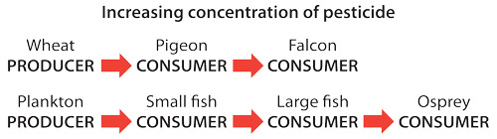

Biomagnification in action

Example 1: Falcon eggs

DDT is a non-biodegradable, accumulative pesticide. The indiscriminate spraying of DDT in the 1960s threatened wildlife, birds in particular. The use of DDT resulted in a decrease in the number of peregrine falcons, which became an endangered species in the 1970s.
The high levels of DDT found in the tissues of these birds of prey caused them to lay very thin-shelled eggs, which broke easily and resulted in a low survival rate of the chicks. Fortunately, DDT is now banned in most developed countries, allowing populations of birds of prey to increase and birds like the peregrine falcon to be removed from the endangered list.

Example 2: 'Operation Cat Drop'

The following is an example of how the biomagniﬁcation of DDT can affect a food chain. To eradicate malaria-carrying mosquitoes in the Borneo states of Malaysia, the inside of village huts were sprayed with DDT and dieldrin. Malaria was eradicated but the villagers soon noted that the thatched roofs of the sprayed huts were rotting away. This was due to an increase in the population of thatch-eating moth larvae which avoided DDT-sprayed food, and a decrease in the moth's natural enemy, a parasitic wasp, which had been affected by the spray.
At the same time there was an increase in the population of rats following the death of local cats who were dying from an accumulation of DDT. The cats had been eating geckos which had eaten DDT-contaminated cockroaches - and the result was biomagnification. The cat population was restored through 'Operation Cat Drop' after the Royal Air Force parachuted cats into the villages. With the cat population restored, the increase in rats and the threat of diseases such as typhus and plague were countered.

Example 3: Chernobyl nuclear disaster

The following is an example of radioactive fallout that may persist in the environment for many years. This ecological disaster occurred in 1986 when an explosion in a nuclear reactor released clouds of radioactive material including caesium-137 and strontium-90. These pollutants were carried by winds to many European countries. Wind and rain spread the radioactive pollutants across the land and into rivers and lakes.
The radioactive pollutants were taken up by plants through the roots and accumulated in the plant tissue, which was then transferred to consumers along the food chain.

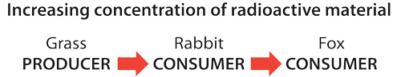

Due to biomagniﬁcation top predators, such as the wolf and the fox, were exposed to contamination levels twelve times greater than the herbivores they ate further down the food chain. Domestic animals that grazed on contaminated forest pastures also accumulated radiation in their meat products and their milk.
Radiation will continue to be spread through ecosystems via dust produced during ploughing, forest ﬁres, wind erosion, water and food chains. Large areas of agricultural land are still excluded from use due to contamination. The radioactive material will persist in these ecosystems for many decades due to their long half-lives.

Half-life: Time taken for radioactive material to be reduced to half its original mass.
For example: caesium-137 has a half-life of 30 years, which means it would take 30 years for an original mass of say 100 gm of caesium to be reduced to 50 gm and another 30 years to become 25 gm and so on.

Climate Change

Climate Change is the change in the average pattern of weather over a long period of time. The period of time which is considered long enough to estimate climate is 30 years or more. Greenhouse gases play an important role in determining climate and causing climate change.

“The Science of Climate Change: Questions and Answers August 2010”, Australian Academy of Science, Canberra, is available on Moodle for you to read. This document aims to summarise and clarify the current understanding of the science of climate change. Here is the Summary taken from this document.

Summary
The Earth’s climate has changed. The global average surface temperature has increased over the last century and many other associated changes have been observed. The available evidence implies that greenhouse gas emissions from human activities are the main cause. It is expected that, if greenhouse gas emissions continue at business-as-usual rates, global temperatures will further increase significantly over the coming century and beyond.
The science behind these statements is supported by extensive studies based on four main lines of evidence:

Physical principles established more than a century ago tell us that greenhouse gases, such as carbon dioxide (CO2), trap heat and keep the planet warmer than it would otherwise be. Increasing greenhouse gas levels raise the temperature of the Earth’s surface.

The record of the distant past (millions of years) tells us that we cannot take a stable climate for granted. Climate has varied greatly through the Earth’s history. It has, for example, gone through 10 major ice age cycles over approximately the past million years. The past few thousand years have been unusually stable. Together with our understanding of physical principles, evidence from the past shows that climate can be sensitive to small external influences.

Measurements from the recent past (the last 100 years) tell us that the Earth’s surface is warming along with rising levels of greenhouse gases from human activities, and that this warming is leading to other environmental changes. Although climate varies from year to year and decade to decade, the overall upward trend of average global temperature over the last century is clear.

Climate models, together with physical principles and knowledge of past variations, tell us that, unless greenhouse gas emissions are reduced and greenhouse gas concentrations in the atmosphere are stabilised, global warming will continue.
Climate models estimate that, by 2100, the average global temperature will be between 2°C and 7°C higher than pre-industrial temperatures, depending on future greenhouse gas emissions and on the ways that models represent the sensitivity of climate to small disturbances. Models also estimate that this climate change will continue well after 2100.

A 2°C global warming would lead to a significantly different world from the one we now inhabit. Likely consequences would include more heat waves, fewer cold spells, changes to rainfall patterns and a higher global average rainfall, higher plant productivity in some places but decreases in others, disturbances to marine and terrestrial ecosystems and biodiversity, disruption to food production in some regions, rising sea levels, and decreases in Arctic ice cover. While aspects of these changes may be beneficial in some regions, the overall impacts are likely to be negative under the present structure of global society.
A warming of 7°C would greatly transform the world from the one we now inhabit, with all of the above impacts being very much larger. Such a large and rapid change in climate would likely be beyond the adaptive capacity of many societies and species.

There are uncertainties in climate science. For example, a precise value cannot be given for the likely range of warming because of uncertainties in climate sensitivity to small disturbances, although climate models and evidence from past climate change provide a plausible range of values. Climate changes over small regions and changes in rainfall patterns are very hard to estimate. Tipping points or rapid climate transitions associated with overall global warming are possible but cannot yet be predicted with confidence. These uncertainties work in both directions: there is a chance that climate change will be less severe than the current estimates of climate science, but there is also a chance that it will be more severe.

PRACTICE QUESTIONS:
1. Nodularia is a producer. Name three other producers mentioned in the food web of the Peel-Harvey Estuary.

2. When Nodularia blooms it forms a thick mat on the surface of the Estuary. How will this affect the seagrass growing on the Estuary bed?

3. Where is the phosphorus run-off that enters the Estuary most likely to have come from?

4. A large percentage of the catchment area for the Peel-Harvey Estuary has been cleared for farming. What effect will this have on the phosphorus run-off into the Estuary?

5. What are non-biodegradable pollutants and how do they affect food webs?

The diagram below shows the amount of DDT present at each level of a food chain
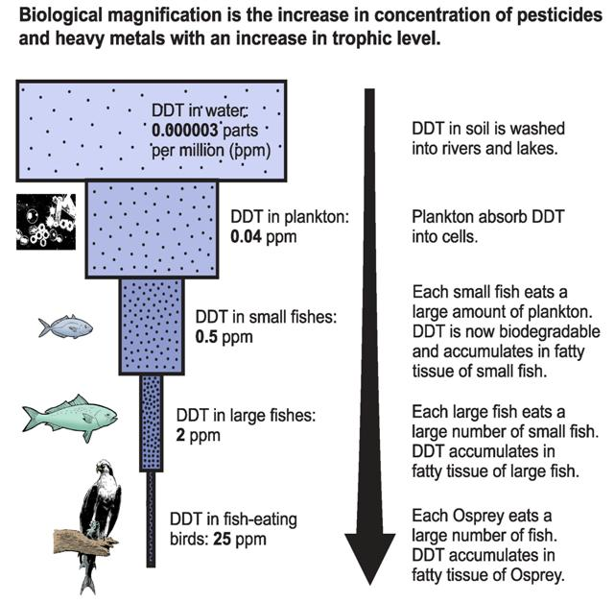

The increase in DDT concentration for each step can be calculated as follows:
Water to Plankton Calculation: 0.04/0.000003 ppm = 13333.3
Increase or magnification of DDT from water to plankton = x 13 thousand

6. Calculate the increase in DDT concentration at each step in the food chain below.
a) water to small ﬁsh

b) water to large ﬁsh

c) water to fish-eating birds (osprey)

7. From your knowledge of food pyramids and trophic levels, explain how the transfer of non-biodegradable pollutants differs from the transfer of other matter such as nutrients.

8. Esperance is a coastal town in the south of Western Australia. In 2007 a government inquiry investigated the deaths of 4000 birds, high lead levels among local residents and lead contamination of the town's water supply. The cause was due to the transport of lead ore, in the form of dust and in open trucks, from Wiluna (900km inland) to Esperance. Lead dust was being blown over the town and coastal areas.

a) Explain how the arrival of lead at Esperance resulted in the death of 4000 birds.

b) Suggest one other way to explain how a heavy metal pollutant, such as lead, might enter a food chain.

Source: EdWest Sem1 2017
9. Identify two major causes of climate change and describe two global effects of such change.

Source: Academic Task Force Sem1 2019
10. Land salinisation in Western Australia is primarily a result of:

- Clearing of deep rooted native vegetation
- Excessive irrigation of the land
- High levels of erosion of top soil
- Use of fertilsers in agricultural and urban ecosystems

11. The following is a list of factors involved in a eutrophication event.

Point | Explained
1 | Abundance of autotrophs stops light entering water
2 | Increased levels of nitrates and/or phosphates enter the waterway
3 | Breakdown of dead plant material depletes oxygen resources in water
4 | Promotes growth of aquatic autotrophs
5 | Death of autotrophs
6 | Leads to death of heterotrophs

Four students sequenced the list in what they thought was the correct order. Which student was most correct?

- Student 1 - 1, 2, 3, 4, 5, 6,
- Student 2 - 1, 5, 6, 3, 2, 4,
- Student 3 - 2, 4, 5, 1, 3, 6
- Student 4 - 2, 4, 1, 5, 3, 6

12. Numerous gases act as greenhouse gases with each gas having a specific global warming potential (GWP). The GWP compares the amount of heat trapped by a given mass of the gas when compared to an equivalent mass of CO2.

The table below shows details of four different gases global warming potentials.

Gas | GWP
Carbon dioxide (CO₂) | 1
Methane (CH₄) | 21
Nitrous oxide (N₂O) | 310
Hydrofluorocarbon -23 (HFC-23) | 11 700

If equivalent quantities of radiant energy were shone onto equal sized containers of oxygen holding the following gases, which would heat up the LEAST?

- Container 1 – holding 100 g of CO₂
- Container 2 – holding 10 g of CH₄
- Container 3 – holding 1 g of N₂O
- Container 4 – holding 0.01 g of HFC-23

Practice Extended Response
Source: EdWest Sem1 2019
13. Matter and energy move through an ecosystem in different ways.
Describe these different ways and explain how the difference produces the ecological effect of biomagnification.

The enhanced greenhouse effect activity: Part A
Carbon dioxide is generated in this experiment following the reaction of sodium bicarbonate with vinegar in a plastic bottle.
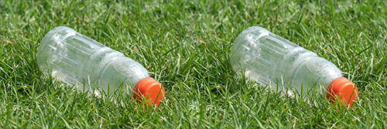

Materials required:

- Plasticine
- Vinegar – 4 tsp
- Bicarbonate of Soda – 2 tsp
Plasticine & thermometers are provided in your kit.
- Table salt – 2 tsp
- 2 x 300 mL thermometers (alcohol)
- 2 x 2 L PET, clear plastic drink bottles
- Plastic wrap
- Bright/hot sunlight
- Graph paper

Method
- Label one bottle ‘no CO₂’ and label the other bottle ‘CO₂’.
- Use the plasticine to form two ‘corks’ that can be used to seal each bottle.
- Carefully make a small hole in the plasticine corks and poke the thermometers through the holes so that when they are placed in the bottles the bulb is in the middle of each bottle.
- In the bottle labelled ‘CO₂,’ carefully pour in two teaspoons of bicarbonate of soda and then two teaspoons of vinegar. Quickly place the cork (with thermometer) into the neck of the bottle to stop any of the carbon dioxide from leaking.
- In the bottle labelled ‘no CO₂’, carefully pour in two teaspoons of salt and then two teaspoons of vinegar. Quickly place the other cork (with thermometer) into the neck of the second bottle.
- Place the bottles in the sunlight.
- Take an initial reading and record this as your time ‘zero’ in the results table.
- Record the temperature of the two thermometers (in °C) every five minutes for thirty minutes and record in the results table below.

Time (min) | Start (0) | 5 | 10 | 15 | 20 | 25 | 30
Temperature (°C) in ‘No CO2’ bottle.
Temperature (°C) in ‘CO2’ bottle.

Graph the temperature inside each of the bottles on the same graph using different colours or symbols to represent the different bottles.

Heading:

Question 1
What conclusions can you make about the effect of carbon dioxide on temperature in the bottles?

Question 2
What inferences can you make about the effect of carbon dioxide on temperature in the atmosphere?

Question 3
Use your graph to determine the temperatures in each bottle at 12 minutes and 35 minutes.

Question 4
Why was vinegar added to the bottle labelled ‘no CO2’?

Question 5
Why was salt added to the bottle labelled no ‘CO2’?

Question 6
What is the independent variable in this experiment?

Question 7
What is the dependent variable in this experiment?

Question 8
List three variables you controlled in this experiment.

Question 9
Write a hypothesis for this experiment.

Question 10
If possible, compare your results to others who have completed the same activity.

The enhanced greenhouse effect activity: Part B

Rising carbon dioxide levels since 1750 have been plotted in the graph below. The atmospheric carbon dioxide concentrations are taken from ice core samples for the pre-1958 data. The carbon emissions are estimated gaseous CO₂ emissions from fossil fuel consumption, gas flaring and cement production. No data is available for pre-1750 but it can be assumed that the emissions would have been similar, or less than that in 1750.

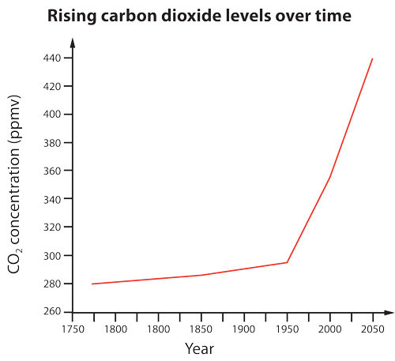
Question 1
What human activities are assumed to be the primary cause of the increased carbon dioxide emissions from 1750?

Question 2
What human activities are assumed to be the primary cause of the increased carbon dioxide emissions from the late 1940s?

Question 3
Use the graph to predict the CO2 concentration (ppmv) for 2050.

“The Science of Climate Change: Questions and Answers August 2010”, Australian Academy of Science, Canberra, is available on Moodle.

Read through this document which aims to summarise and clarify the current understanding of the science of climate change for non-specialist readers. The document is structured around seven questions.

Answer each question, using your own words, and then compare your answers to those below.

1. What is climate change?

2. How has Earth’s climate changed in the distant past?

3. How has climate changed during the recent past?

5. Are human activities causing climate change?

6. How do we expect climate to evolve in the future?

7. What are the consequences of climate change?

8. How do we deal with the uncertainty in the science?



